Lab 1b: Add and Use Custom Skills

In this lab, you will add and use custom skills to fetch data from a database. Using this, you will be able to query from the recent sales and inventory data.

Add custom skills

1. Go to the menu from watsonx orchestrate home page.

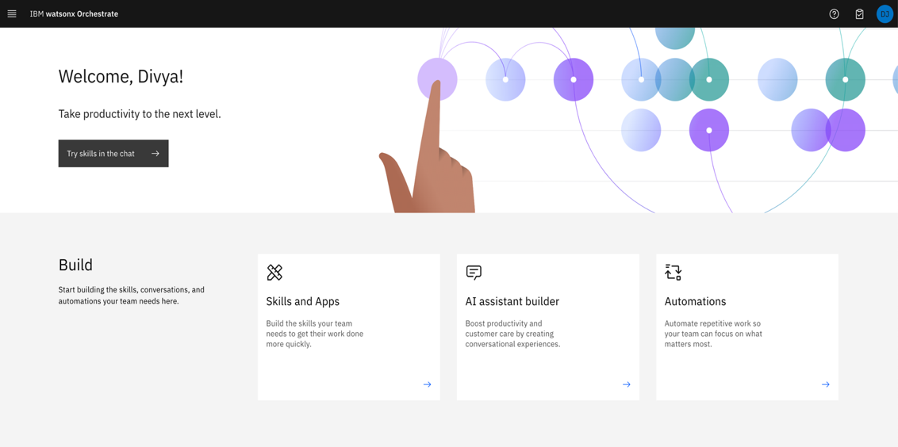

2. Go to Skills and apps.

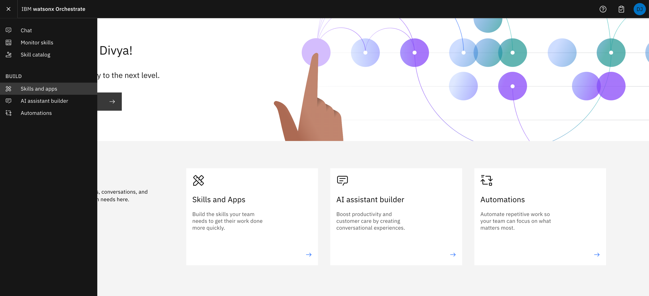

3. Go to “Skills” tab.

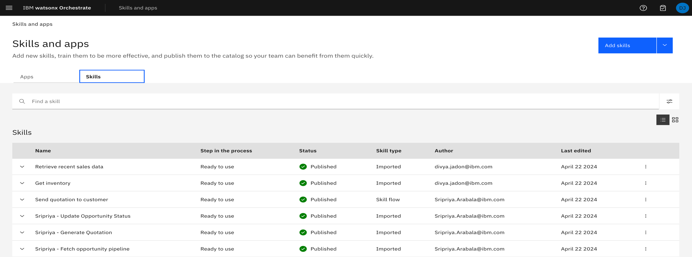

4. Click on “Add skills”.

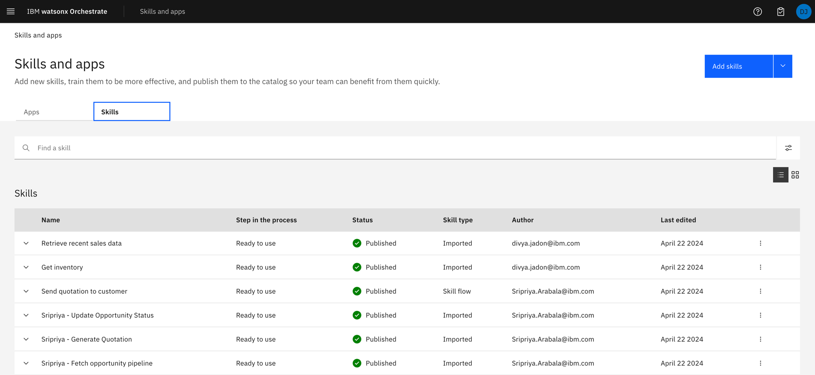

5. Click on “From a file”.

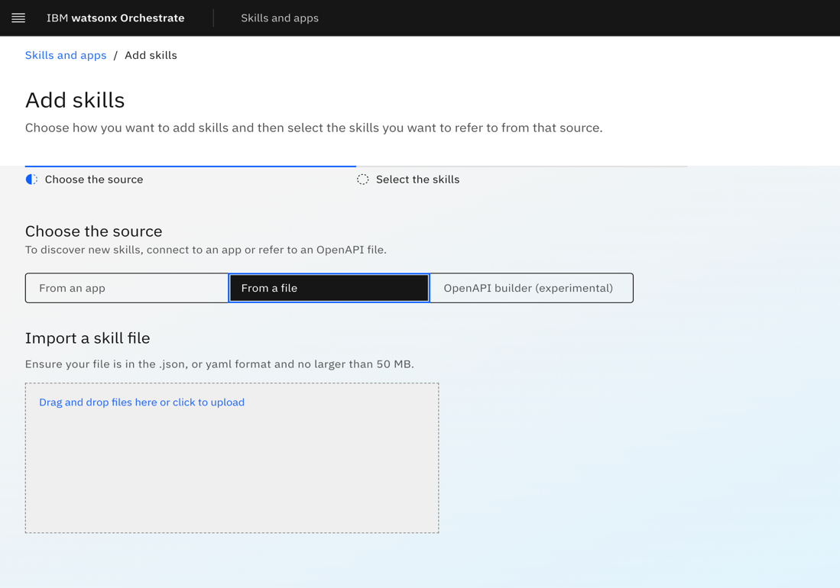

6. In “Drag and drop files here or click to upload” section, upload openapi file/skill file. Before, uploading you need to make some changes in openapi file, as shown below so that one file doesn’t override the other’s file.

6.1 Update get_recentsales.json file

6.1.1 Open get_recentsales.json file in a text editor.

6.1.2 Update highlighted text to add your name in title (line 4), description (line 5), summary (line 24) and operationid (line 25) values. Please note there should be no spaces in operationid value.

Update title to “[Your Name] Sales text to sql API”

Update description to “[Your Name] Sales text to sql API”

Update summary to “[Your Name] Get Recent Sales”

Update operationid to “[Your Name]Sales”

6.1.3 Save the file.

6.2 Update get_inventory.json file

6.2.1 Open get_inventory.json file in a text editor.

6.2.2 Update highlighted text to add your name in title (line 4), description (line 5), summary (line 24) and operationid (line 25) values. Please note there should be no spaces in operationid value.

6.2.3 Save the file.

7. Upload get_inventory.json in “Drag and drop files here or click to upload”.



8. Click on “Next”.

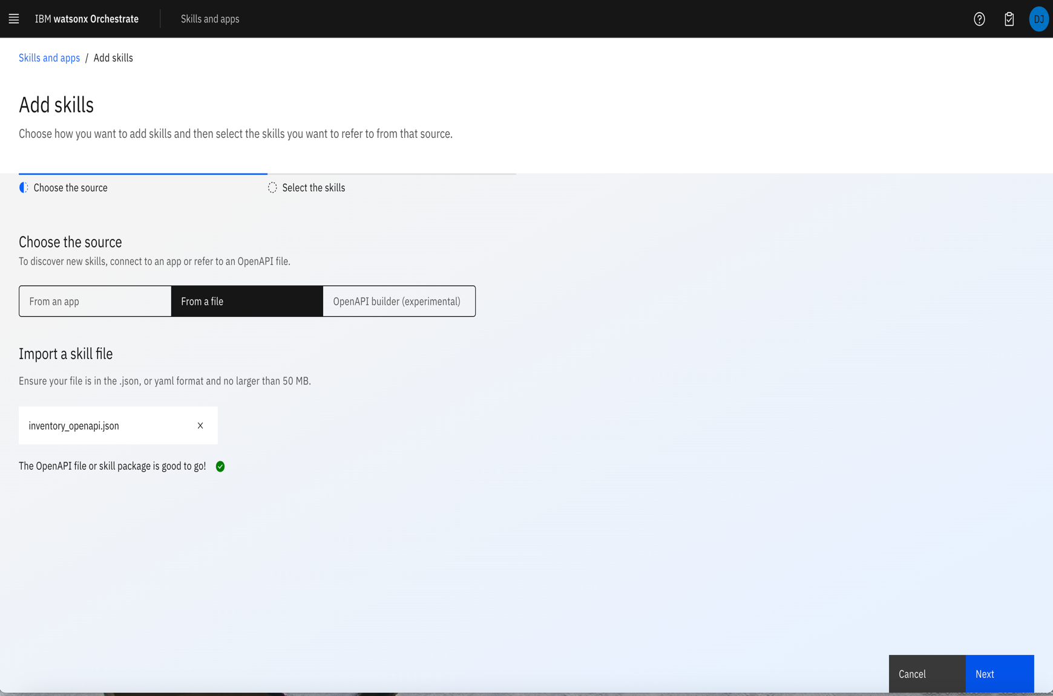

9. Check the box.

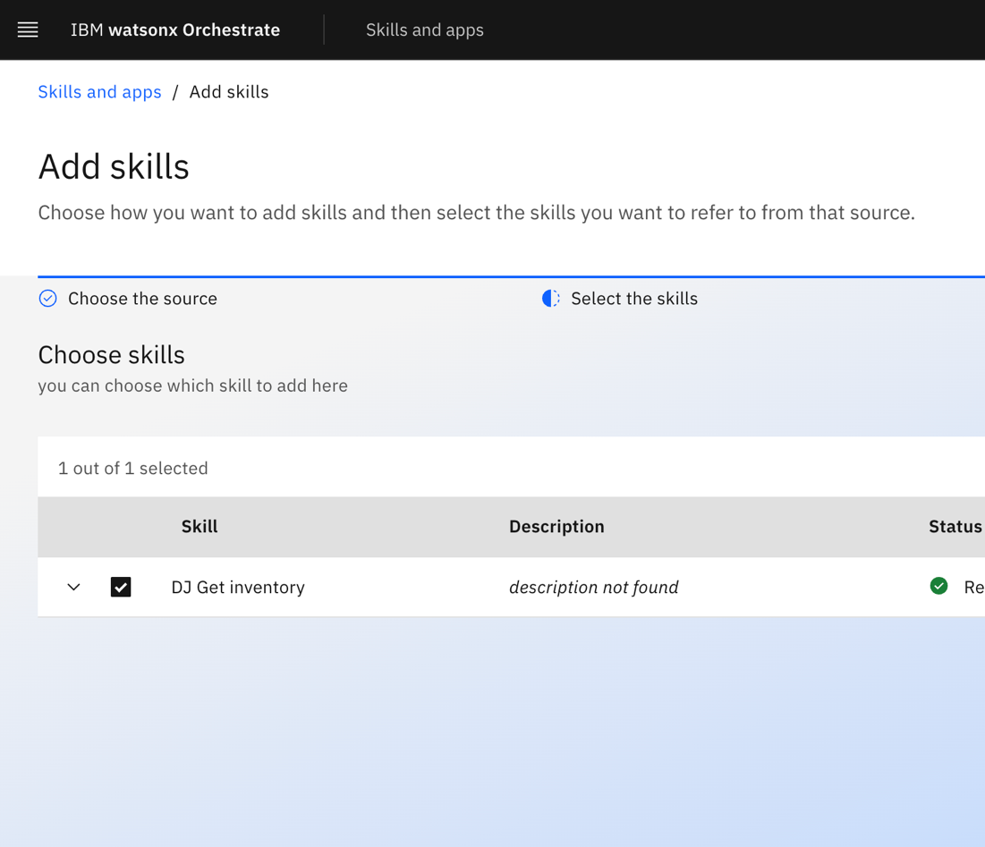

10. Click on “Add”.

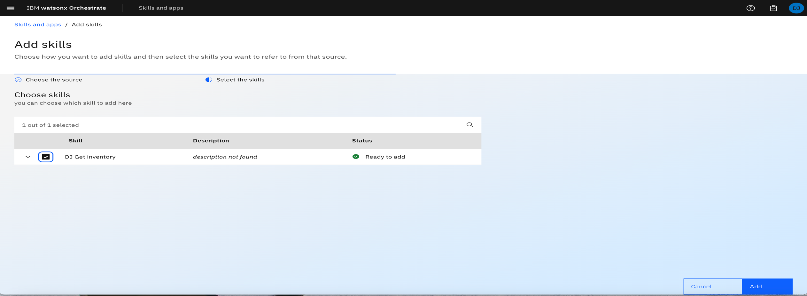

11. Status should be “Ready to publish”.

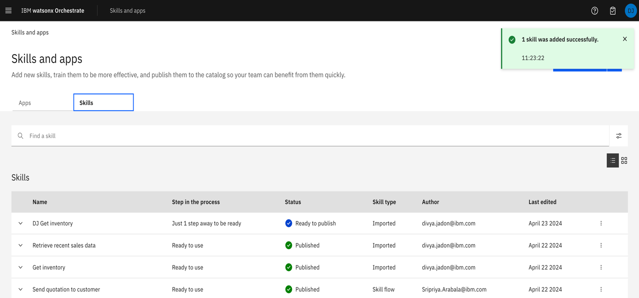

12. Click on three dots and then “Enhance this skill”.

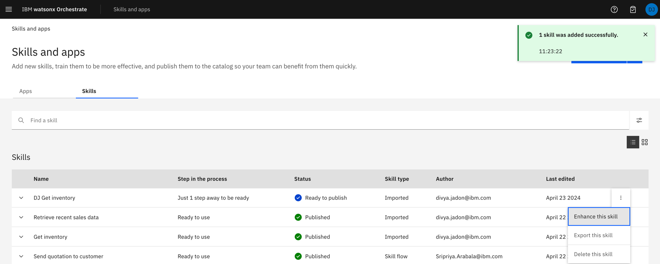

13. Click on “Publish”.

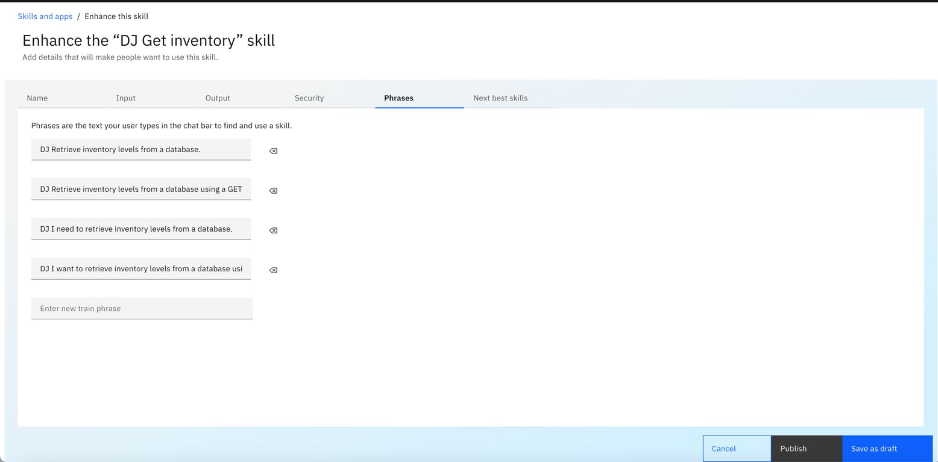

14. The status changes from “Ready to publish” to “Published”.

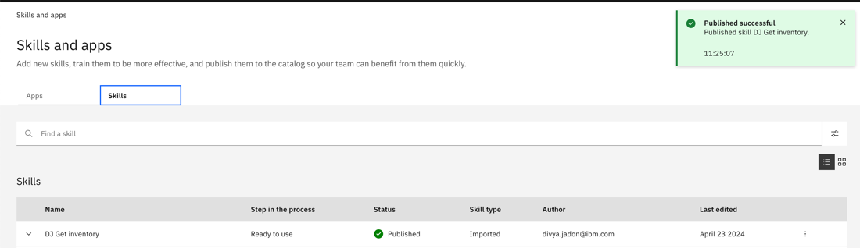

15. Repeat steps from 7 to 14 for “get_recentsales.json” file.

16. Two custom skills are published.

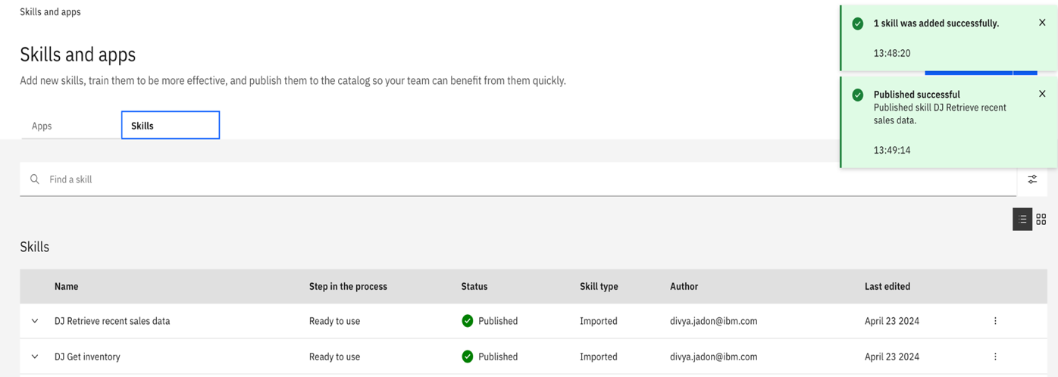

Use skills

1. Click on chat from the menu

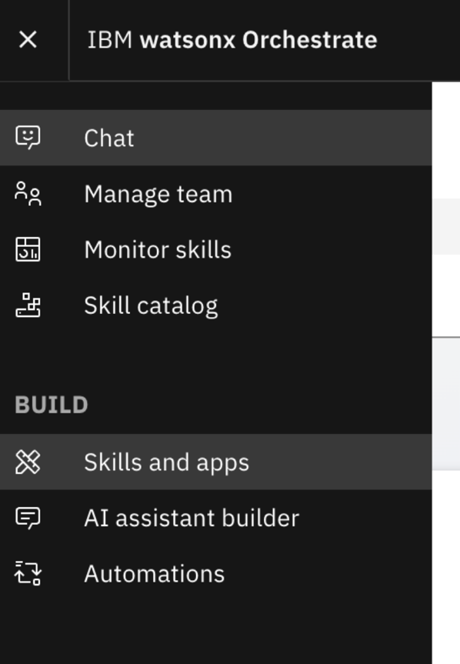

2. Check on “Add skills from the catalog” section.

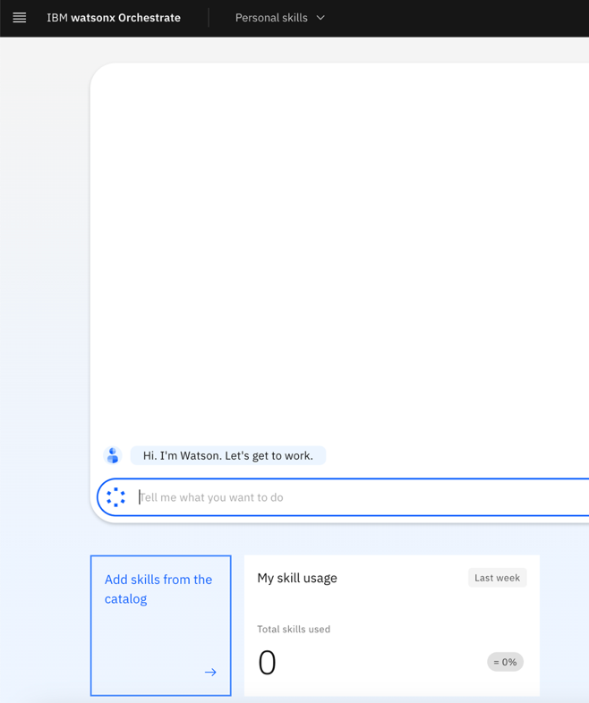

3. Under “All Apps” search for “[Your Name] Get Inventory”.

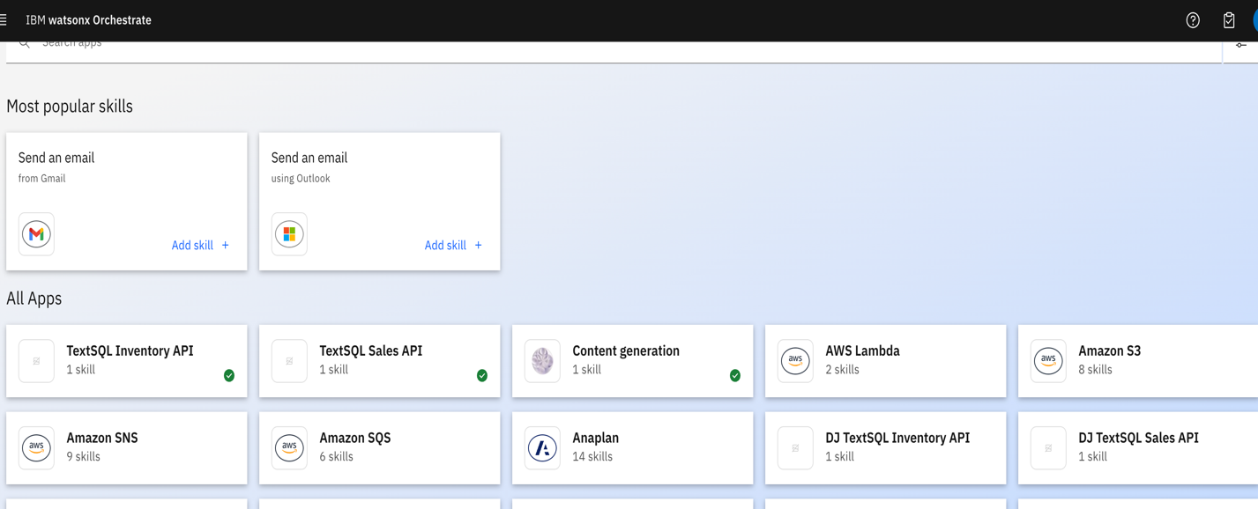

4. Click on “Add skills”.

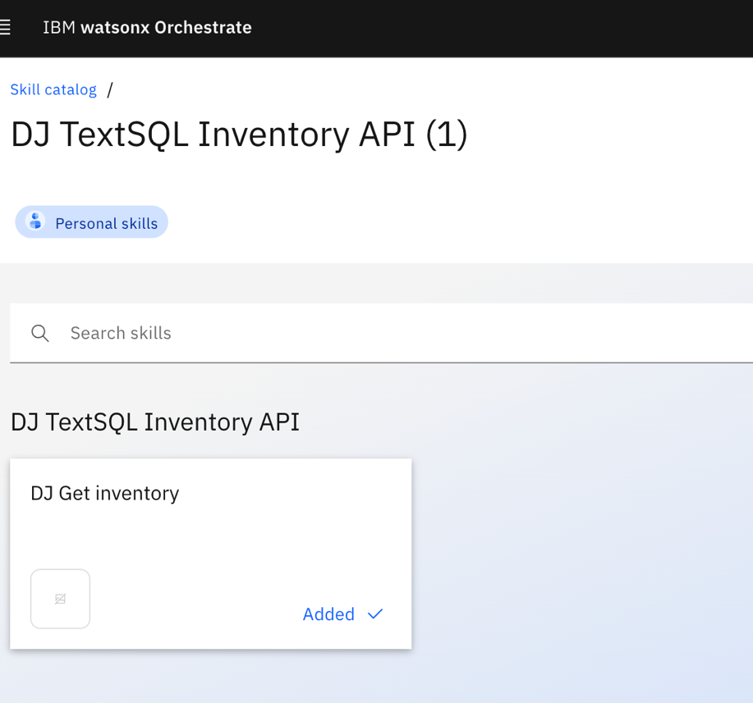

5. Click on “Connect app”.

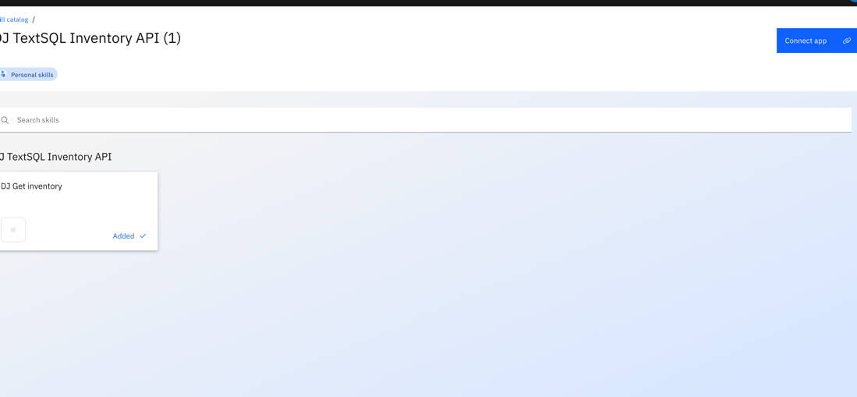

6. Write your IBM ID username and password, then click on “Connect app”.

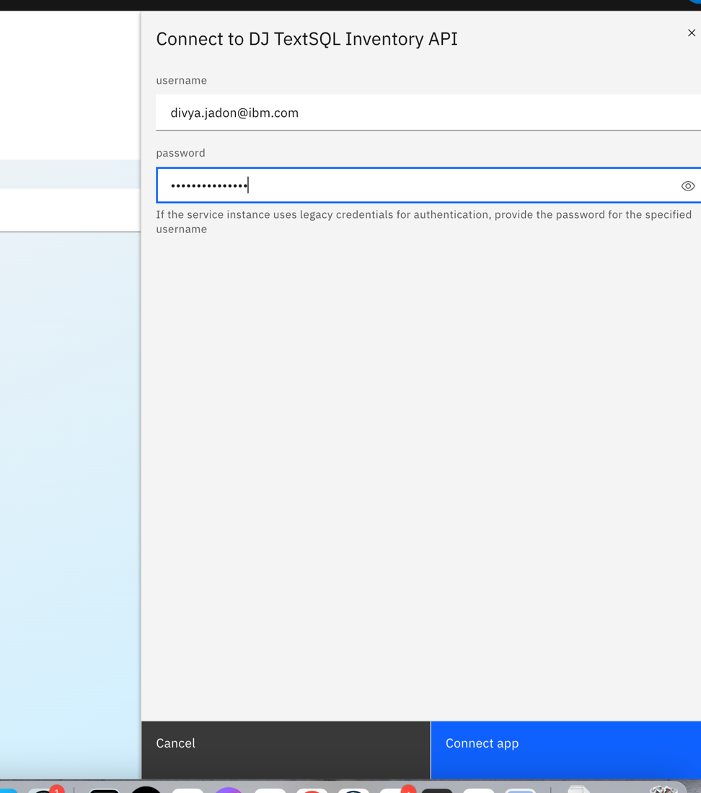

7. Similarly, repeat steps 3-6 to connect to “[Your Name] Get Recent Sales”. Now, both skills are added in Skill Catalog.

8. Go to Chat from menu again.

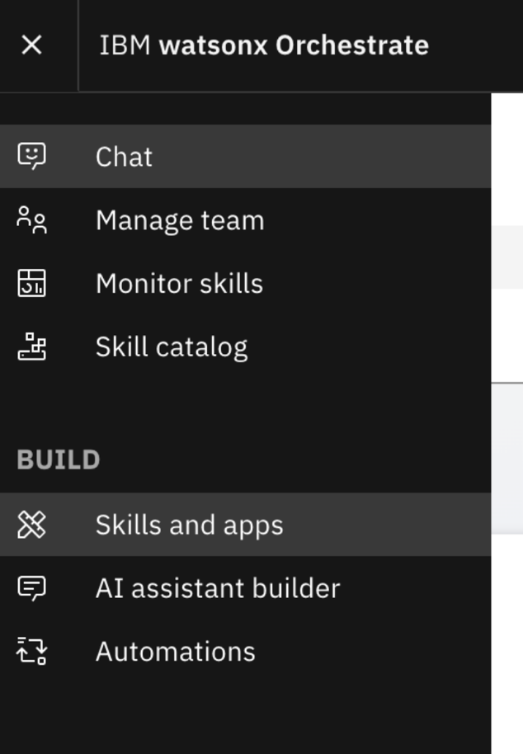

8. Click on “[Your Name] Get Inventory”.

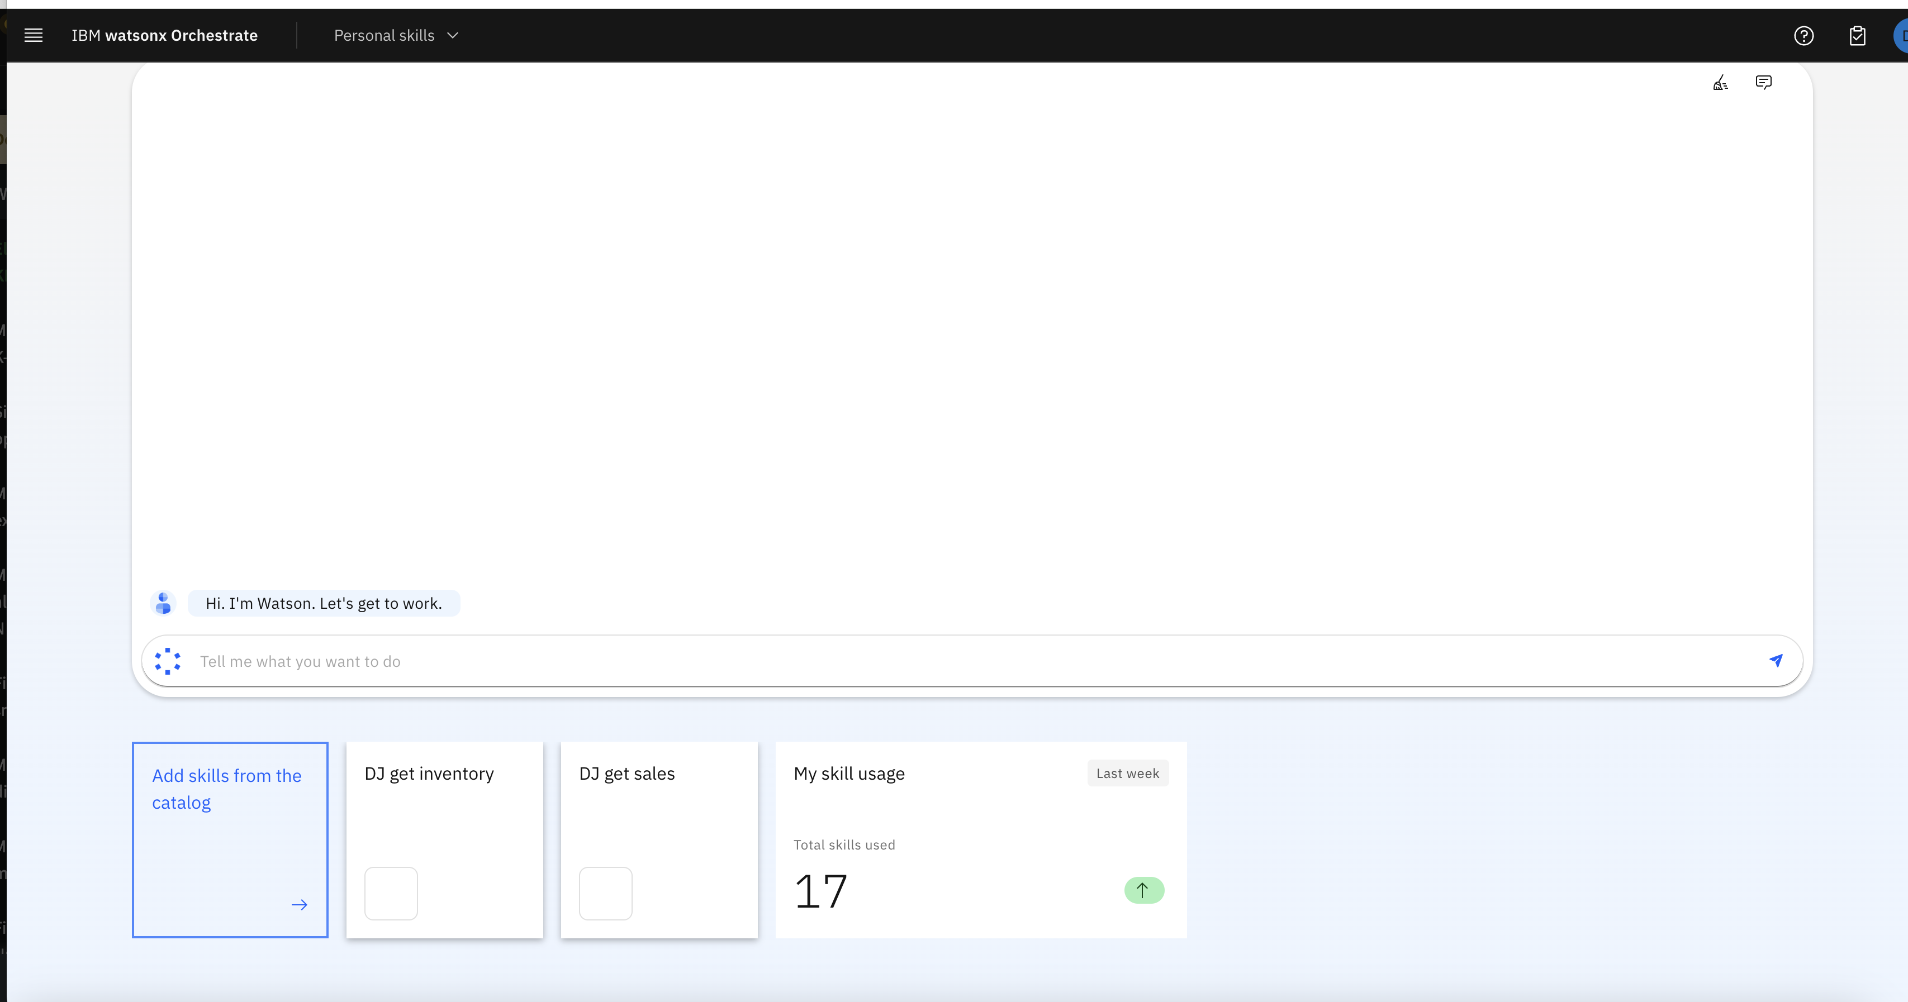

9. Type the question “What is the inventory level of Xtralife?” in Query box. Then click on “Apply”.

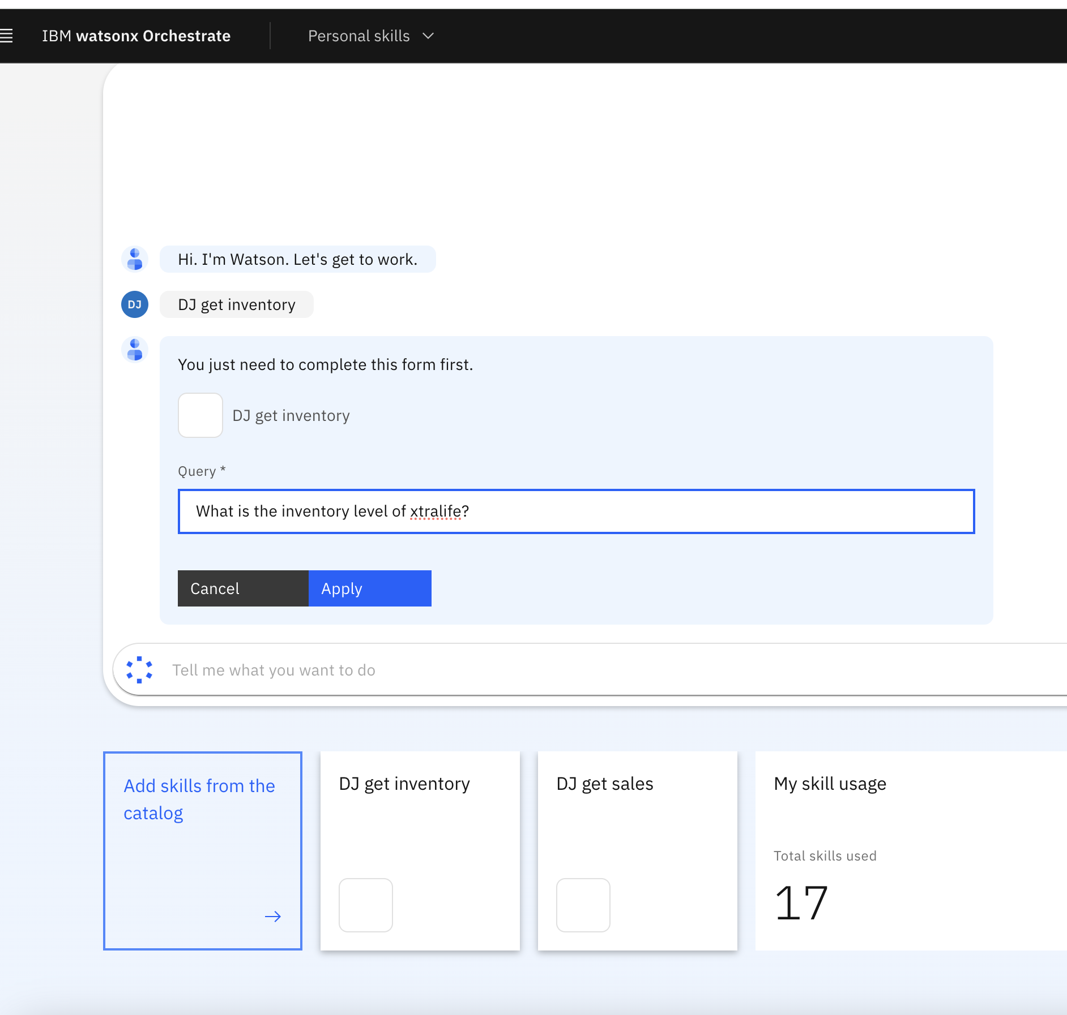

10. Similarly, you click on “[Your Name] Get Recent Sales” and ask query “What is the monthly sales for Xtralife for last 3 months?” and click on apply to view the results.

